* For the infrastructure requirements, since their clients are from London, they can use the **eu-west-2** region.
* Additionally, for the VPC, they can use a CIDR block of 10.0.0.0/16 which supports 65,536 IPs for future scaling since there is the possibility of adding an application servers' subnets and load balancer subnet in the future.
* For two subnets (Web and Database) with about 4000 servers each, we can design our subnets this way:
  + **Public Subnets** (Web Tier):
    - 10.0.1.0/20 (AZ-1) → 4,094 IPs (Web Servers 1-2000 + ALB)
    - 10.0.17.0/20 (AZ-2) → 4,094 IPs (Web Servers 2001-4000)
  + **Private Subnets** (DB Tier):
    - 10.0.32.0/20 (AZ-1) → 4,094 IPs (DB Servers 1-2000)
    - 10.0.48.0/20 (AZ-2) → 4,094 IPs (DB Servers 2001-4000)
* For security requirements, we will be using MySQL database in this use case
* **Web Servers SG**:
  + - Inbound:

HTTP (80) from 0.0.0.0/0

SSH (22) from TCS Admin IPs only

* + - Outbound: MySQL to Database SG
* **DB Servers SG**:
  + - Inbound:

MySQL (3306) from Web Servers SG

SSH (22) from Web Servers SG only

* + - Outbound: N/A
* **Internet Access**
  + - **Public Subnets**:

Internet Gateway (IGW) attached to VPC

Route table: 0.0.0.0/0 → IGW

* + - **Private Subnets**:

No IGW access which differentiates the public from private subnets based on what we’ve been taught.

* **Load Balancing**
  + - Located in public subnets
    - Listens on HTTP/HTTPS
    - Routes traffic to Web Servers across AZs

Here is a diagrammatic representation of the deployment below:

<https://drive.google.com/file/d/1ik4s5ypuTH6nns0rG-VoOGuseOipiL2E/view?usp=sharing>

Additionally, from the AWS console, the deployment is also illustrated below:

VPC:

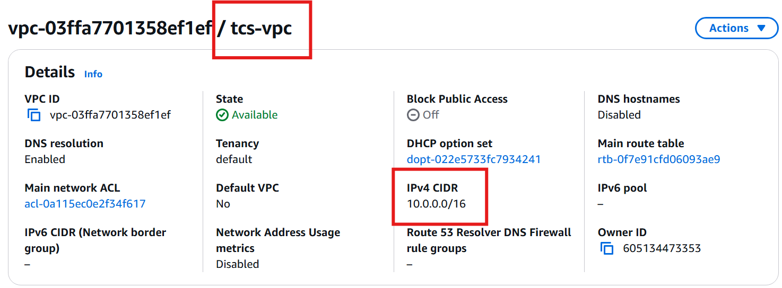

Subnets:

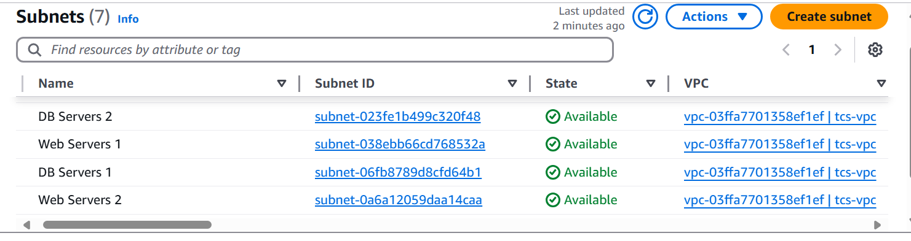

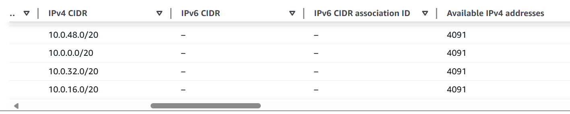

Internet Gateway:

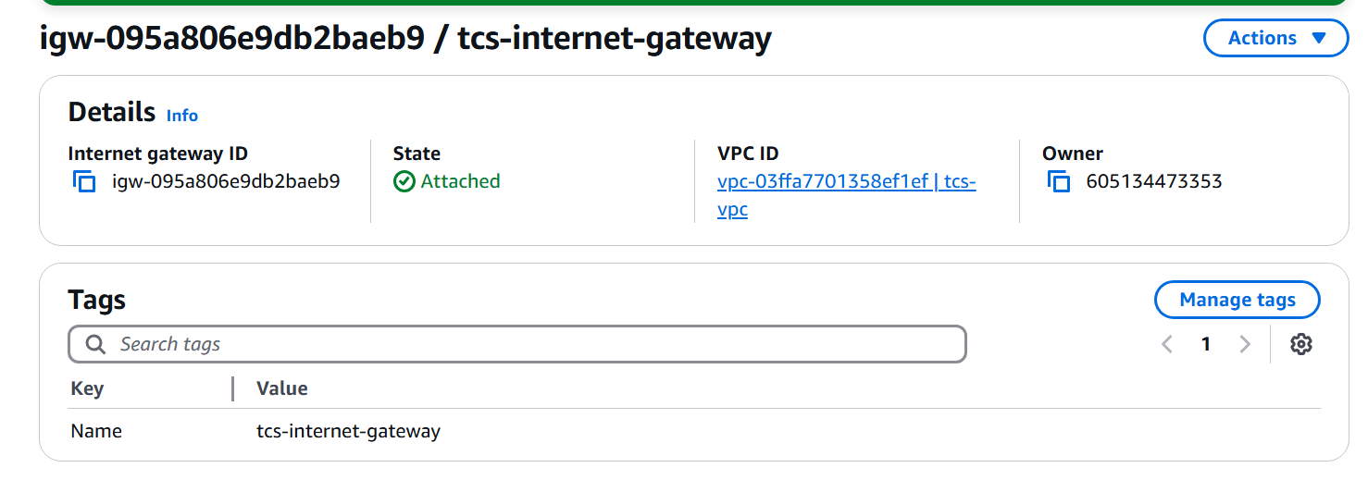

Route Table associated with the public subnets only for internet access:

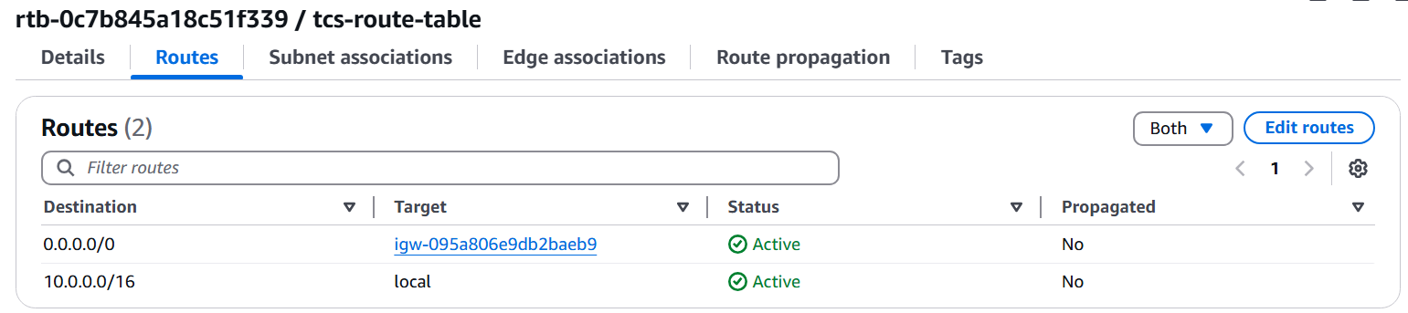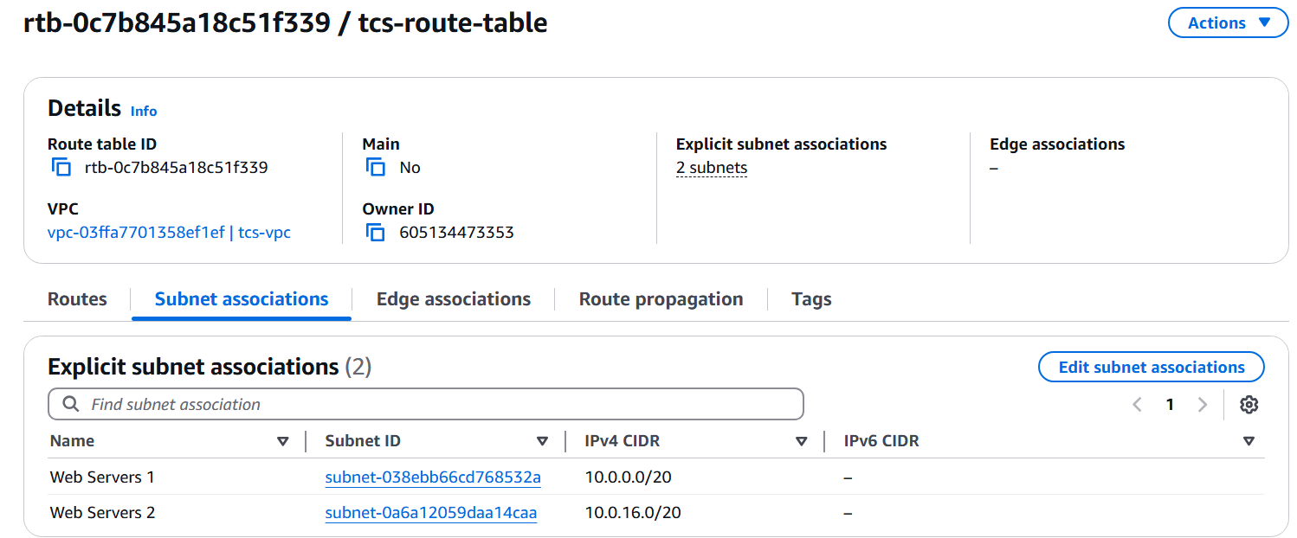

Route table for Private Subnets will be the main route table with only VPC route:

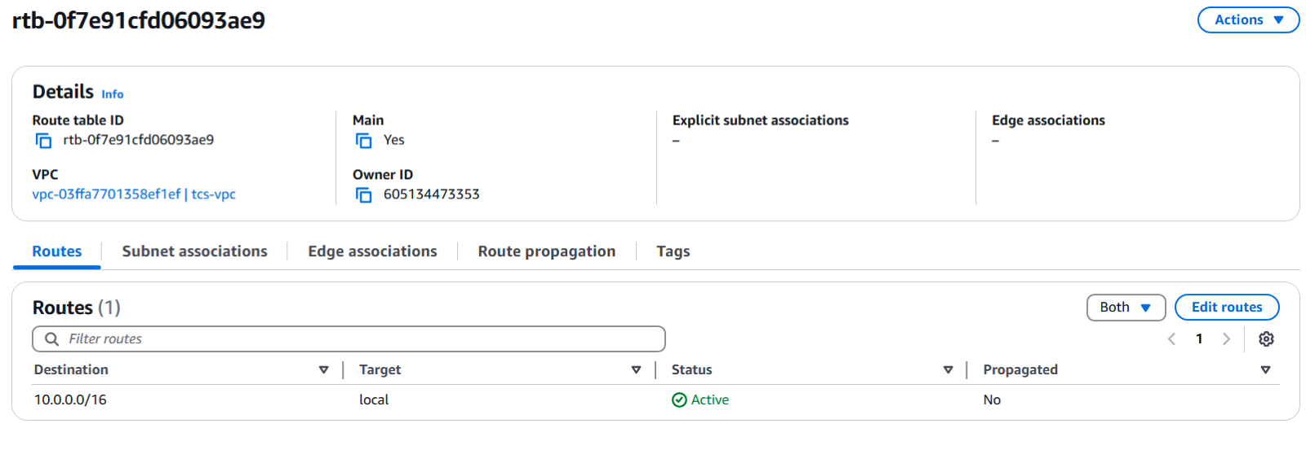

Security Groups associated with the web and DB servers:

